CS251: Software Engineering I

**Software Design**

**Specification**

**For**

**Bingo**

**Prepared by**

**Team Name: A2M2**

**Versions History**

|  |  |  |  |
| --- | --- | --- | --- |
| **Date** | **Version** | **Description** | **Author(s)** |
| **15/11/2014** | **1.0** | **Initial version** | **A2M2** |

**Approved by:**

**Eng. Mohammed Arnaoty**

Contents

[Team](#_Toc402855163) 4

[Document Purpose and Audience](#_Toc402855164) 4

[System Models](#_Toc402855165) 5

[System Decomposition](#_Toc402855166) 5

[Class diagrams 6](#_Toc402855167)

[Sequence diagrams](#_Toc402855169) 7

[Class - Sequence Usage](#_Toc402855170) 10

[User Interface Design](#_Toc402855172) 11

[Screen 1 – Main Interface](#_Toc402855173) 11

[Screen 2 – Play Interface 12](#_Toc402855174)2

[Screen 3 – Score Interface](#_Toc402855175) 13

[Ownership Report](#_Toc402855177) 13

# Team

|  |  |  |  |
| --- | --- | --- | --- |
| **ID** | **Name** | **Email** | **Mobile** |
| 20120363 | Mahmoud Mohamed Gamal | [mandolove200@gmail.com](mailto:mandolove200@gmail.com) | 01100841259 |
| 20120256 | Amr Abo El-Aila | [aboelala.amr@gmail.com](mailto:aboelala.amr@gmail.com) | 01117908593 |
| 20120352 | Mahmoud Hamdy Sayed | [ma7moud\_7amdy18m@yahoo.com](mailto:ma7moud_7amdy18m@yahoo.com) | 01114044592 |
| 20120260 | Amr Sameh Raafat | [amr4159@gmail.com](mailto:amr4159@gmail.com) | 01113288609 |

# Document Purpose and Audience

* **This document is the Software Requirements Specification (SRS) for Bingo Game. SDD usually accompanies an architecture diagram with pointers to detailed feature specifications of smaller pieces of the design. It is designed and written for stakeholders: professors and project developers.**

# System Models

## System Decomposition

**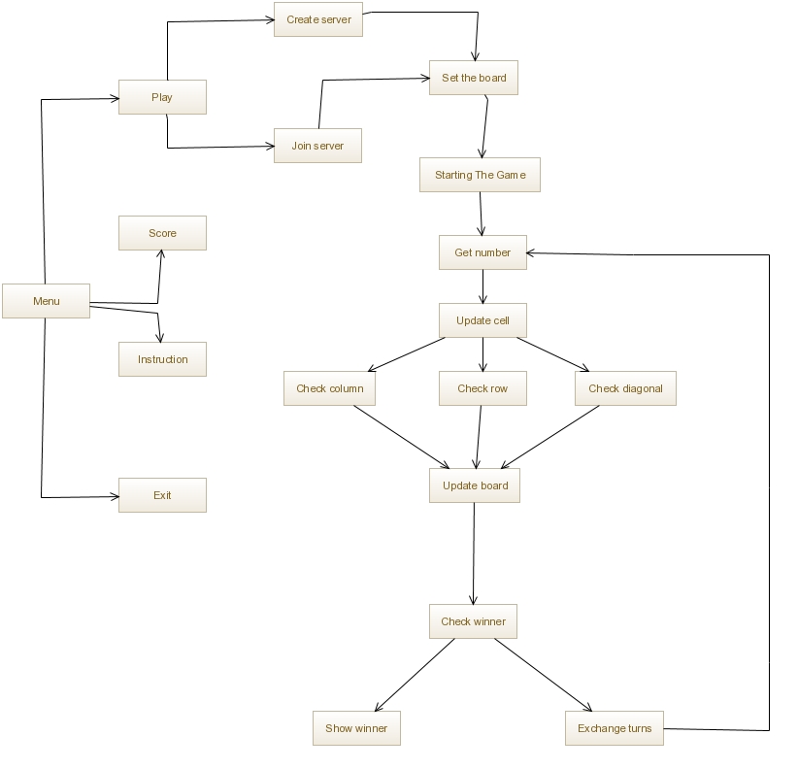**

## Class diagram

## C:\Users\user\Desktop\10850868_827930107253940_1621973844_n.jpg

\*Note: System can’t be divided into sub systems because the server is taken place on one of user’s device.

## Sequence diagrams

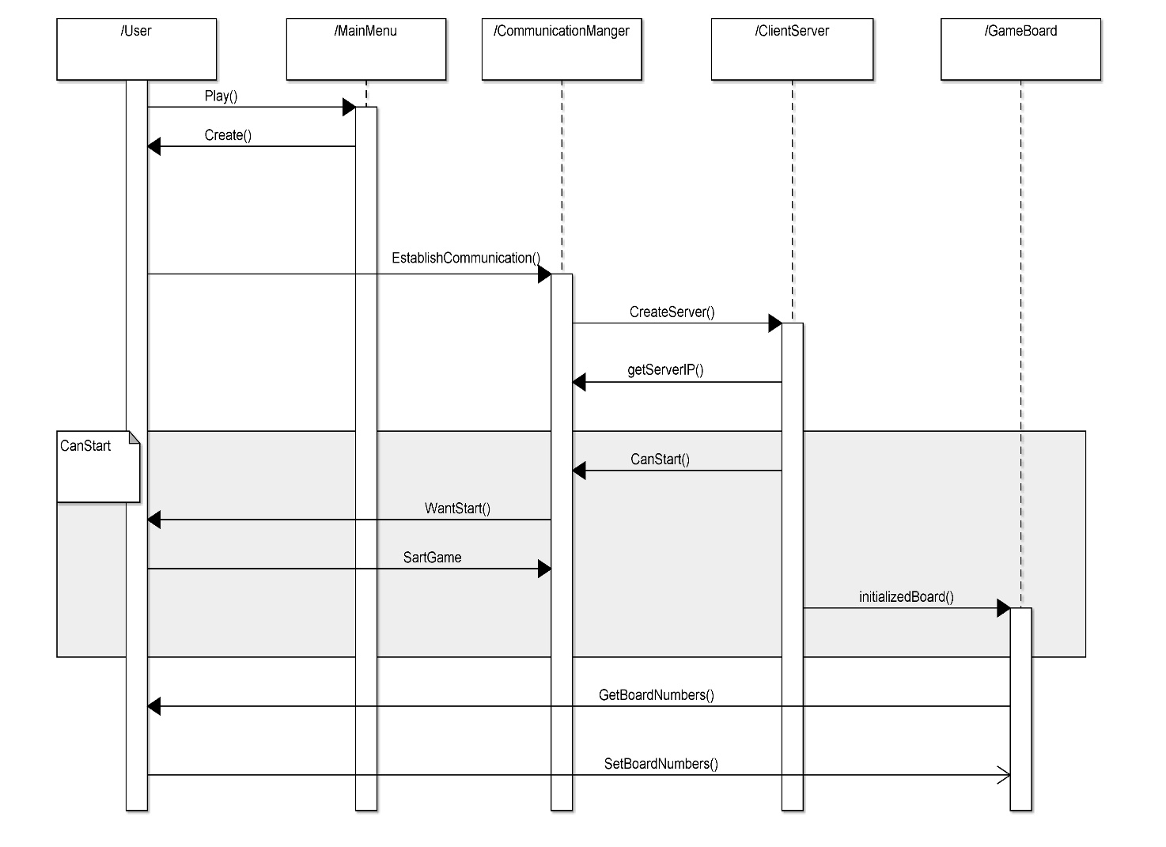

### 

### C:\Users\user\Desktop\2.jpgC:\Users\user\Desktop\3.jpg

### Class - Sequence Usage

| **Class Name** | **Sequence Diagrams** | **Overall used methods** |
| --- | --- | --- |
| Server | 1.1 , 1.2 | Create\_Server , Join\_Server |
| Board | 1.1.1 , 1.2.1 , 3.1.1 , 3.1.2 , 3.1.3 , 3.1.1.1 , 3.1.2.1 , 3.1.3.1 | Set\_Board , Update\_Board , Check\_Row , Check\_Column , Check\_Diagonal |
| Bingo | 2 , 2.1 , 3 , 3.1 , 4 , 4.1 , 4.2 , 4.2.1= , 5 | Starting\_The\_Game , Get\_Number , Update\_Cell , Check\_Winner , Exchange\_Turns , Show\_Winner |

## User Interface Design

### Screen 1 – Main Interface

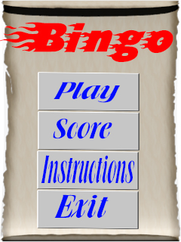

### Screen 2 – Play Interface

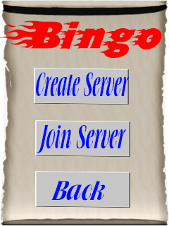

### Screen 3 – Score Interface

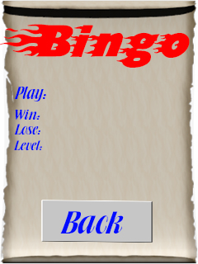

# Ownership Report

|  |  |
| --- | --- |
| **Item** | **Owners** |
| Document purpose and Audience , Sequence Diagrams , User Interface Design | *Mahmoud Mohamed Gamal , Amr Sameh Rafaat* |
| System Decomposition , Class Diagrams | *Mahmoyd Hamdy Sayed , Amr Abo El-Aila* |